# Answers to Questions from P2.1

Name: Lau Ngoc Quyen

Student ID: 104198996

## Is the font type in helloworld2.html similar to helloworld.html (you created in the first week)?

* The font type in helloword2.html completely different with the font type in helloworld.html that I created in 1.2 Pass task.

## What happens if you remove <div class="container"></div>?

**Before removing <div class = “container”></div>:**

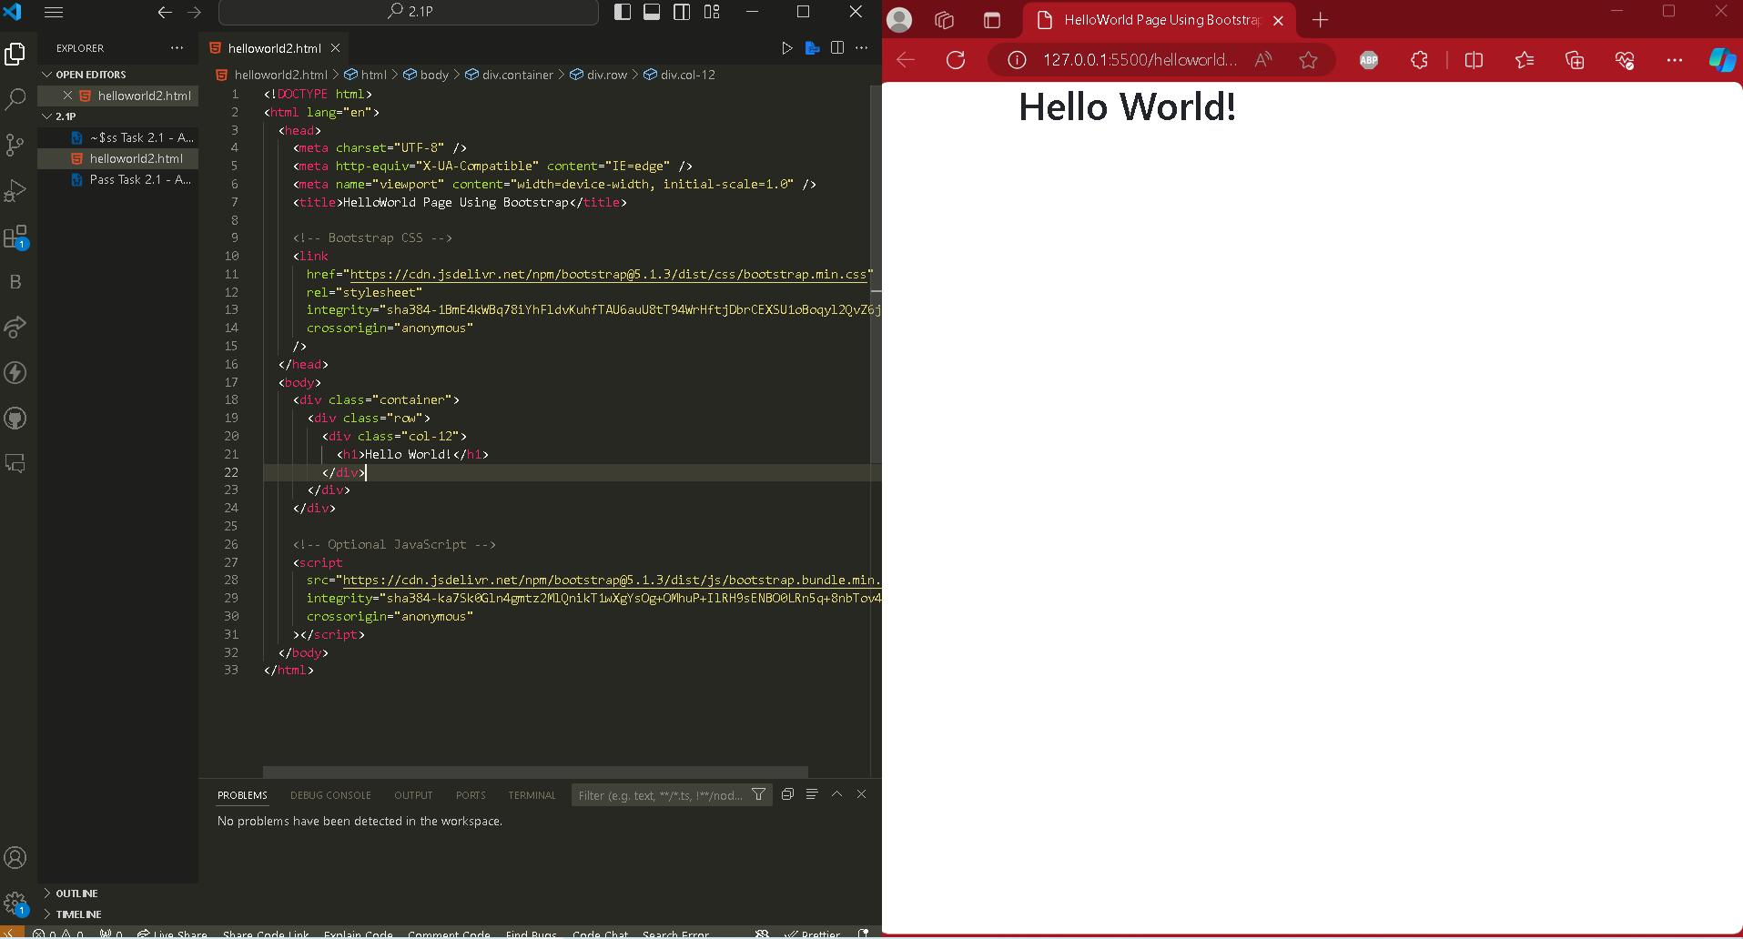

**After removing <div class = “container”></div>:**

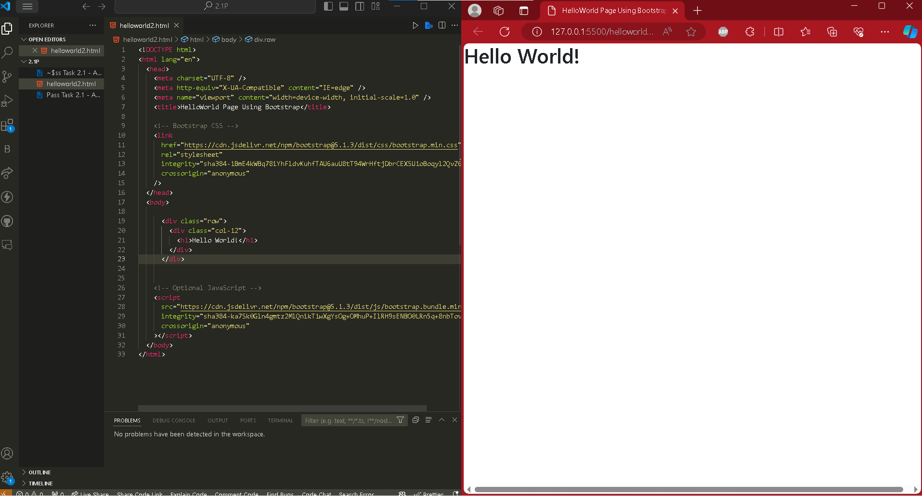

* Without <div class="container"></div>, the content will not be centered and will span the full width of the page. The text will align to the left side of the viewport, losing the padding and structure provided by the container, which results in a less organized layout.

## What is the purpose of <div class="container"></div>?

* The <div class="container"></div> serves as a responsive fixed-width container that adapts to the viewport size. It ensures the content is centered horizontally and provides consistent horizontal padding. This creates a structured layout, maintaining the design's integrity across different devices and screen sizes. The container class is a fundamental part of Bootstrap's grid system, helping to align and organize content within a defined space, enhancing the overall user experience.